Michael Surdek
Project Management Plan
Hightower Global Solutions
Final Project Plan



Submitted to:
Dr. Randy Butler
Project Initiation
Feasibility
Hightower Global Solutions, a firm specializing in financial services technology, is planning to create an intranet portal that will train their 350 globally dispersed sales associates in the many products that they offer. With a wide variety of complex products that is growing further through acquisitions, the company believes a lack of training is causing them to miss sales pitches and other opportunities. By creating this training portal that will help associates meet aggressive sales targets, Hightower is confident that their $1.5 million investment will be worth it in terms of financial metrics such as return on investment and internal rate of return. This project is also feasible for company due to their technical capacity, functional organizational structure, and the fact that it will only require internal resources.
Strategic Goals
The project of creating the intranet portal, which will be called HighLEARN, will help Hightower better accomplish its strategic objectives. Prior to the project, there is immense pressure on the sales associates to become experts on as many products and services as possible. Since their product portfolio is growing in size and complexity through their aggressive acquisition strategy, this pressure is building and sales associates are failing to meet the sales targets that have been set. With the execution of the HighLEARN project, these associates will be better prepared to effectively communicate and pitch potential prospects. Additionally, CEO Carol Bailey believes that connecting people to resources and knowledge in this way will ensure success and sustainability in the global market, which is one of Hightower’s main strategic goals.

Project Charter
The project charter must be completed in order to formally authorize the existence of a project and to authorize the project manager to use resources for the project. The charter outlines the scope, goals, and deadlines at a high level, with enough detail to be continuously used as a reference, but not so much that it is overwhelming. It is important that the charter sets boundaries for the project, highlights uncertainty, and takes all stakeholders into consideration.
Project Title
HighLEARN Sales Training Intranet

Date
09/26/2021

Business Case
To enhance sales associates’ product knowledge and increase the likelihood of meeting aggressive sales targets

Project Purpose
Create an online learning and development portal for the organization’s 350 sales associates

Project Objectives
Hightower's strategic objectives are the following: offer complex services and products to diverse client base, pursue aggressive acquisition strategy and overall growth, and succeed in the global market

Project Deliverables
- Portal Development
  - User Interface Design Complete and Tested
  - Style Sheets for Portal
  - Theme Design for Website
  - Portal Administration Complete and Accepted
  - Administrative Page Groups
  - Administrative Access Control Design
  - Content Management & Coding Complete and Tested
  - Content Display from Repository
  - Content Upload and Functionality
  - Configure/Code Indexing and Functionality
- Infrastructure and Security
  - Architecture Approved for Implementation
  - Servers for Development, Staging, and Production
  - Configure Firewalls
  - Integrate Infrastructure and Security Systems
  - Log-in/Registration System Complete and Tested
  - Create Log-in/User Profiles
- Content Creation and Editing
  - Product Content Modules Completed and Accepted
  - Interviews with Subject Matter Experts (SMEs) and Sales Representatives
  - Product Sales Summaries
  - Sales Case Studies for Content Modules
  - Edit/Film SME Videos
  - Upload Presentations, Demos, and Webinars for Content Modules
- Documentation
  - Development and Document Coding Standards and Procedures
  - Develop Test Acceptance Plans and Procedures
  - HighLEARN Database Test and Acceptance
- HighLEARN Roll-out

Project Personnel
- Tony DiBello, Project Manager
- Ricardo Contin, Director of Learning and Development
- Steve Quan, Hightower IT Operations Specialist
- Shannon Valley, Hightower IT Systems and Security
- Monica Ianucci, Content Specialist
- Jonathan Brant, Content Specialist

Risks
- Website does not meet user requirements or functionality
- Shannon Valley and Steve Quan are not available to contribute to the project until July 15, 2019
- Marketing department has not endorsed the approach; believes they should go with Microsoft® SharePoint® system
- Security of intranet/portal: no external access beyond firewall.

Schedule Summary
Six months from kickoff

Budget Summary
Project cost estimate of $1,500,000

Measurable Success Criteria
- Access and training to intranet for sales associates
- Content development and interaction
- Increased sales opportunities and sales targets met

Other Project Limitations
- Some team members unavailable for first six weeks
- Associates potential unwillingness to learn new tools
- Language and communication barriers and cultural differences

Approval Signatures/Approval Date
Carol Bailey, CEO - 09/26/2021

High-Level Timeline
The high level timeline is the midpoint between the milestone chart and the work breakdown structure. Using the milestone chart, which shows the expected and actual completion of product increments and deliverables, the high level timeline goes into more detail by breaking the increments into smaller tasks and estimating their duration and costs. This timeline can be used to get an idea of the total duration and cost of the entire project. The work breakdown structure is then created from the milestone chart and the high level timeline by breaking the tasks down into work packages, which can be assigned to individuals who are responsible for them. (MindEdge Module Three)
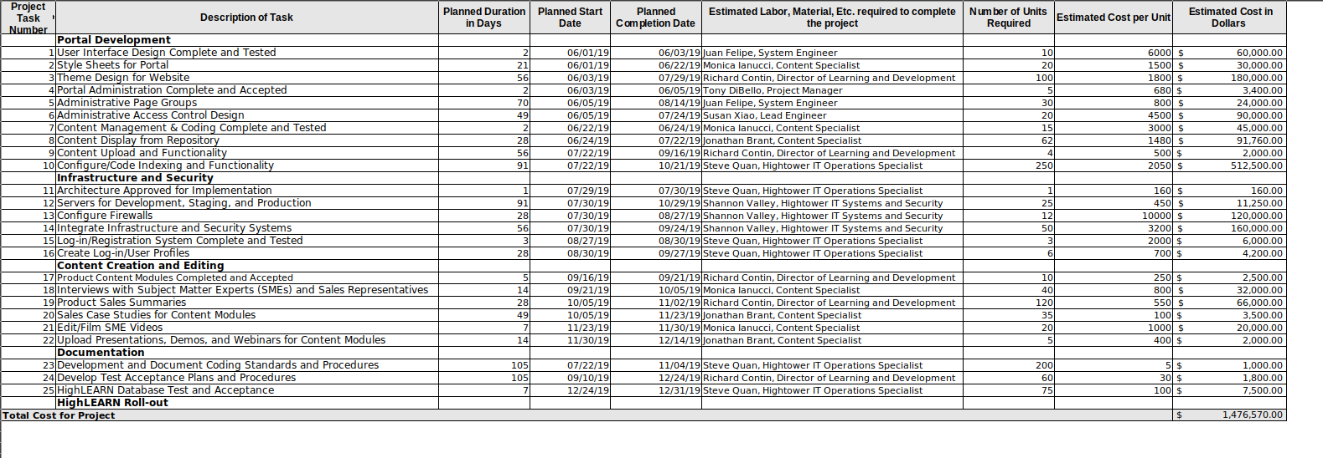
Stakeholder Concerns
It is important to identify and develop a solution for any and all concerns that arise from stakeholders in a project. These should be recorded as soon as they are expressed and they should be updated and tracked in this living document. Each of these concerns is a risk that might cause the project to fail, whether they are large or small, significant or otherwise. Documenting these concerns is a form of stakeholder management and it also makes them more likely to be handled in a way that is satisfactory for the project team and the stakeholders.
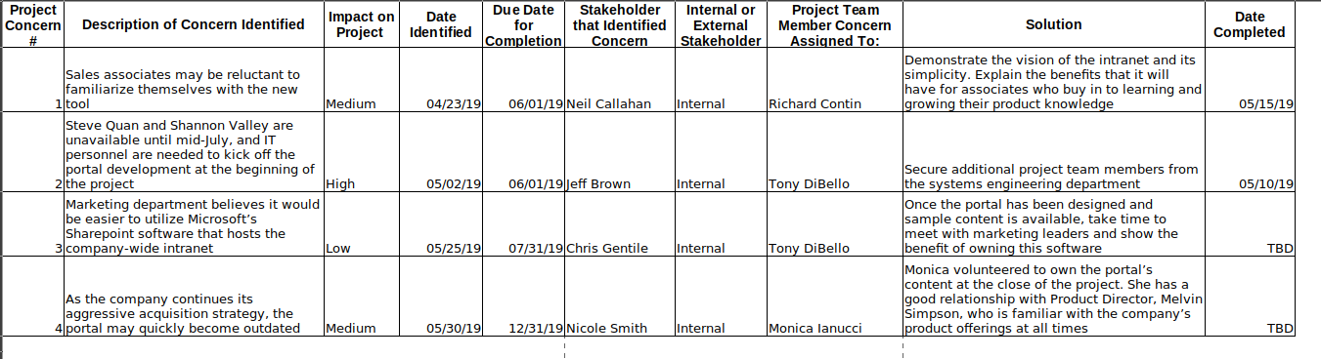

Stakeholder Support
The stakeholder register documents anyone who has something to gain or lose from project execution. These entities can be inside or outside the organization and they may possess differing levels of support and authority. (MindEdge Module Two) It is important to identify stakeholders as early in the process as possible and to keep the register up-to-date throughout the project. The register makes it easier to treat similar stakeholders in a similar fashion. Including each stakeholder’s level of support allows practitioners to ensure that those highly interested are updated on the project’s progress.
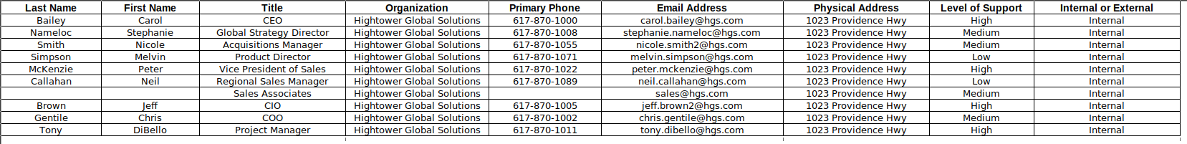

Stakeholder Analysis Template
Stakeholder analysis is a table similar to the stakeholder register, but it mainly includes information that can be used to develop stakeholder management charts such as the power/attitude/interest grid and the salience model. This table and the charts based on it allow the project manager to formulate strategies for engagement and prioritization. In the salience model, stakeholders are placed in zones designated from 1-8 within a Venn Diagram. Stakeholders in any overlapping zones (4-7) are the most important and their suggestions and feedback should be considered highly. Additionally, categorizing stakeholders often helps identify some who were unforeseen and can then be added to the stakeholder register. (Danda)
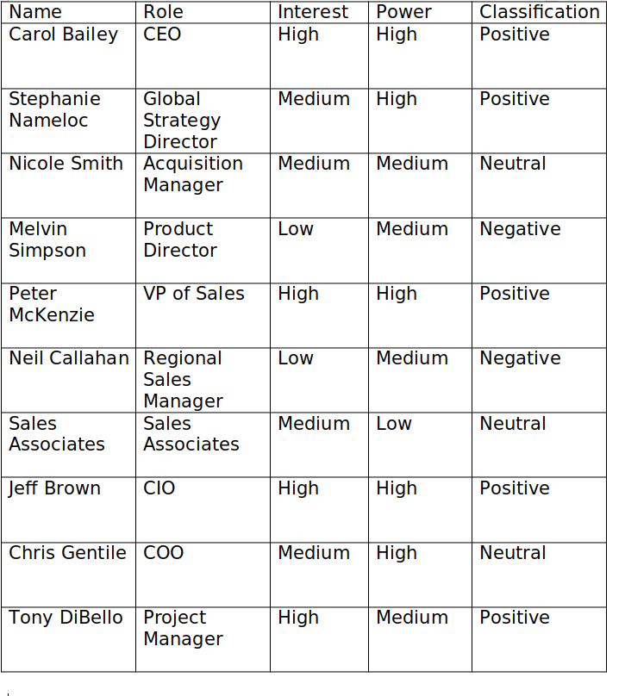
Project Planning
Business Requirements
The HighLEARN intranet project is relatively straightforward in terms of what will be required for the end result to be considered a success. The project includes a few phases that have been planned as well as additional requests and developing situations, which altogether make up the business requirements for the project. It is important to gather and prioritize requirements in the planning phase of the project and throughout the preliminary stages. Doing so “ensures that the scope of the project encompasses all of these needs and that the project will meet the most important stakeholders' requirements to their satisfaction.” (MindEdge Module Three) For Hightower’s project, the basic requirements derive from the activity breakdown and their organizational objectives, including development, IT & security, content creation, and documentation. All of these activities are required for the successful development of the project, but some may be prioritized over others.
Subject Matter Experts
In order to thoroughly plan for the project, it is wise to collect both established and potential requirements with the assistance of subject matter experts. This collection process can include methods such as interviews, questionnaires, diagramming, and reviewing lessons learned from previous projects. The project manager, Tony DiBello, should include project team members and key stakeholders in the process of collecting requirements. He should attempt to gather input from project team members including content specialists, Monica Ianucci and Jonathan Brant, and IT operations specialist, Steve Quan, as well as the company’s executives such as CEO Carol Bailey and CIO Jeff Brown. DiBello should analyze documentation and review lessons learned from previous projects, which will help develop baseline requirements and appropriate questions that will provide effective feedback. He can utilize these questions in interviews with important and readily-available stakeholders as well as in questionnaires with those he cannot access directly. With this input from all relevant parties, DiBello will be able to organize and categorize the project’s business requirements so that they can be referenced and managed throughout the project life cycle.
Standard Requirements Template
Requirement Number | Requirement Description | Priority
1 | Design & Test User Interface | High
2 | Style Sheets for Portal | Medium
3 | Design Theme for Website | Medium
4 | Administer of Page Groups and Access Control | Low
5 | Configure Content Display, Upload, and Coding | Medium
6 | Develop Servers for Staging and Production | Medium
7 | Configure Firewalls | High
8 | Integrate IT systems | High
9 | Complete Registration System and User Profiles | Low
10 | Complete Product Content Modules | High
11 | Interview Subject Matter Experts | High
12 | Utilize Product Sales Summaries and Case Studies | Medium
13 | Edit/Film Subject Matter Expert Videos | High
14 | Upload Presentations/Demos/Webinars | Medium
15 | Document Coding Standards and Procedures | Medium
16 | Test HighLEARN Database | Low
17 | Roll out HighLEARN Portal | High

Format
The format for collecting and documenting requirements is critical to the overall likelihood of success on the project. Requirements must be gathered in a way that not only considers all input, but also ensures that each established requirement is aligned with the organization’s strategic objectives and can be traced to the needs of an individual or group of stakeholders. There are many benefits of strategic alignment and traceability, including better understanding and buy-in, easier access to resources, and more transparency of potential issues and conflicts. Additionally, projects that are well-aligned and traceable become more clear that they are “done” and are more likely to be viewed as a success at completion.
Project Schedule
The project schedule is an important part of the planning phase where key milestones are set to time frames and the duration, costs, and responsible parties are assigned to specific activities. A rudimentary baseline may have been created in the initiating phase, but it can be expanded now that a full list of requirements has been collected. Visualizing the milestones and how they will come together over time can help the project manager with assigning team members to activities, monitoring dependencies, and ensuring that the project can be completed by its proposed due date.
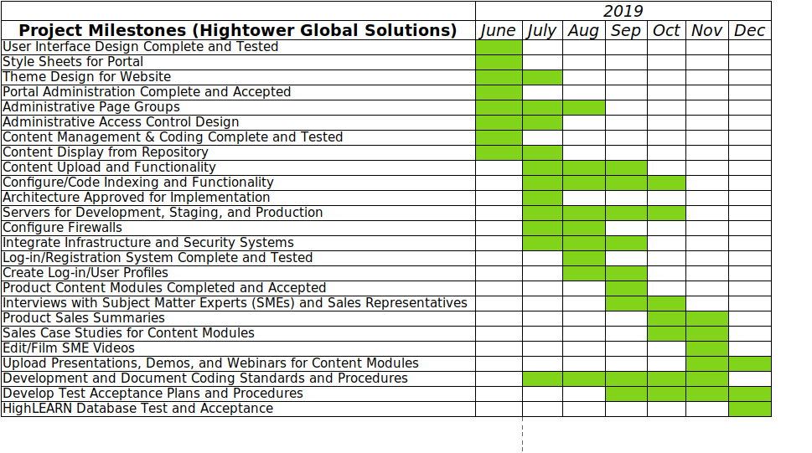

Estimate
Once the milestones have been established along the timeframe of the entire project, the next step for the project manager is to identify the duration of each activity as well as the team member who is assigned to be responsible for the activity’s completion. Tracking this information in the project schedule is important because it becomes a document that can be referenced throughout the execution stage to make sure that things are progressing according to plan and that team members are aware of the responsibilities of others and themselves. When changes inevitably occur on the project, this portion of the project schedule can be referenced to determine whether the changes are feasible and whether they might result in downstream effects to the project.
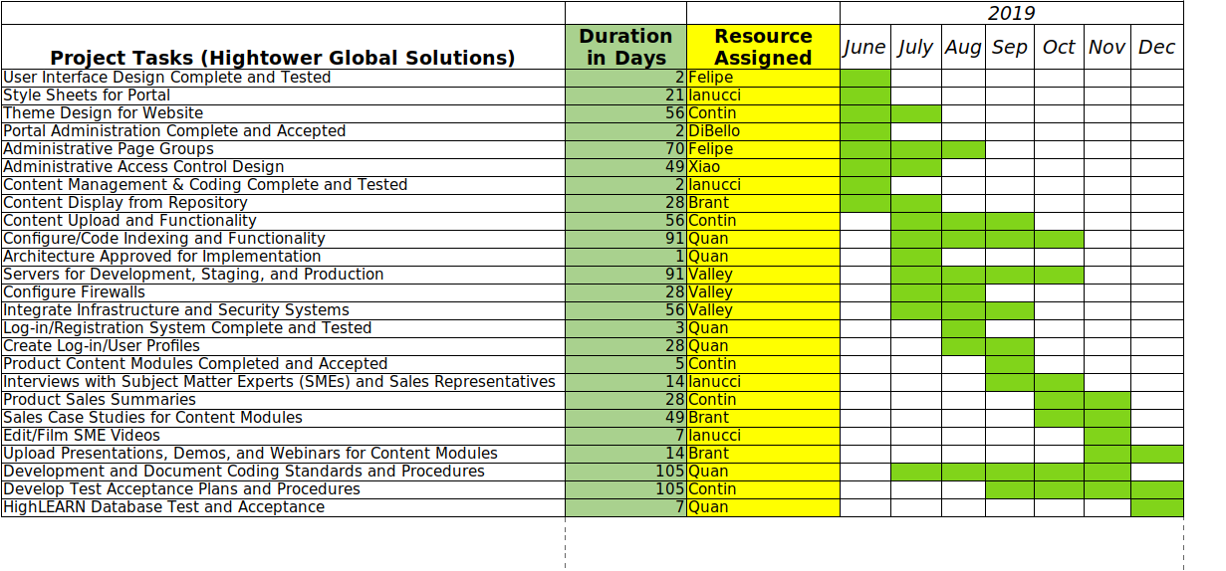

Refine Estimate
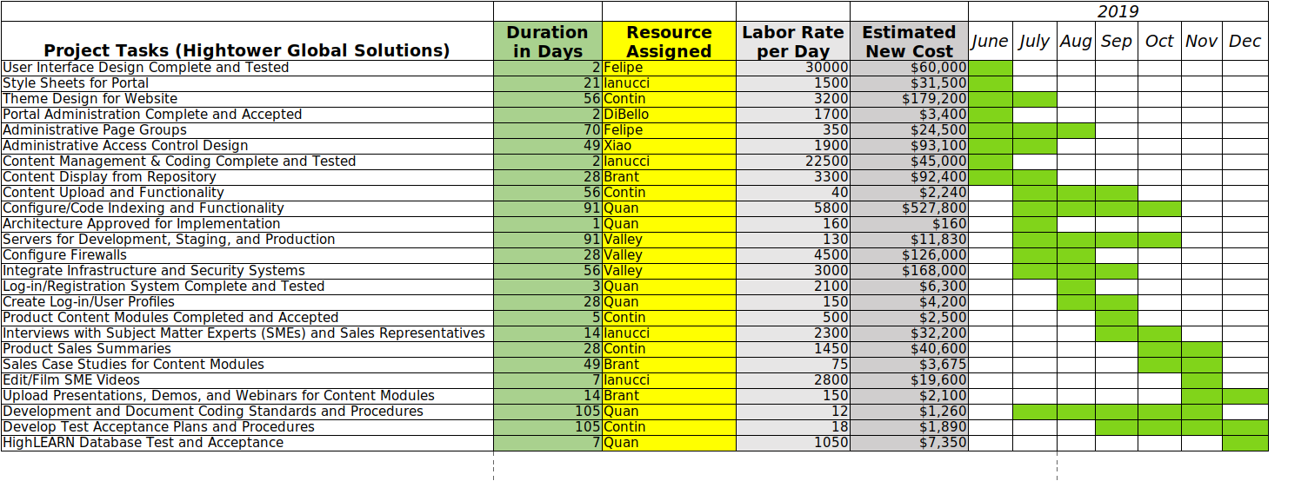
Now that the duration and responsible parties for each milestone have been established, it is possible to estimate the duration cost of labor per day for each task, which provides a better idea of the cost of labor for the entire project. This estimate is often more accurate than the cost baseline that was created in the project charter and the high level timeline. By breaking down each activity’s duration in days and labor rate per day, it is easy to develop a more realistic estimate of how much the project will cost as a whole.
Project Execution
Implementation Approach
With the business requirements and schedule baseline established, now is time to execute the remainder of the HighLEARN project, and the best implementation approach in this case is waterfall project management. In contrast to agile project management, the waterfall method is effective when a project is conceived as a series of sequential steps that are each executed once and not revisited. This makes sense for Hightower’s project because the requirements are established and can be broken down into sequential activities. Waterfall project management “begins with a statement of customer requirements and ends with the creation and consignment of a predetermined deliverable.” (MindEdge Module Three) On this project, the deliverable is an intranet portal complete with resources for over 300 sales associates that cover all of the company’s current offerings. With this approach, DiBello is best able to monitor and control the project throughout each step as they were initially planned.
Project Schedule
When projects face the threat of not being completed on schedule, a practitioner has various options to either rearrange or modify planned activities in order to get the project back on track. Activities can be rearranged so that those originally planned in sequence are executed simultaneously, which is called fast-tracking. The main issue at the beginning of this project is that key IT team members are unavailable for the first month and a half of the project. What makes this a problem is that some of the IT activities are the first things that must be completed and some of the other activities cannot be completed until they are done. This means that, due to the IT activities’ dependencies, fast-tracking is not an option.
The alternatives that involve modifying the IT activities themselves include crashing, resource leveling, and resource smoothing. “Crashing is done by increasing the resources to the project, which helps make tasks take less time than what they were planned for. Of course, this also adds to the cost of the overall project.” (Simmons) In this case, DiBello should choose crashing by finding additional team members who can execute the IT activities until mid-July. Resource leveling is adjusting the start and finish dates in the schedule to align with resource availability and resource smoothing is spreading project activities out among several resources so that work can be completed without exceeding predefined limits. (MindEdge Module 5) If DiBello were unable to secure any additional team members, he would most likely have to apply resource leveling by adjusting the start and finish dates of the project.

Keep Leadership Apprised
Although the HighLEARN project does not involve multiple organizations nor a large number of individuals who are interested in the process and results, it is critical to inform and to hear and acknowledge feedback from anyone who has something to gain or lose from the project. As with many other project elements, thorough planning of this communication effort will help DiBello keep the project on track and make it more likely to be viewed as a success by important stakeholders. The plan should include all of the project's relevant events and individuals, which will ensure that communications are being transmitted in a timely and appropriate fashion.
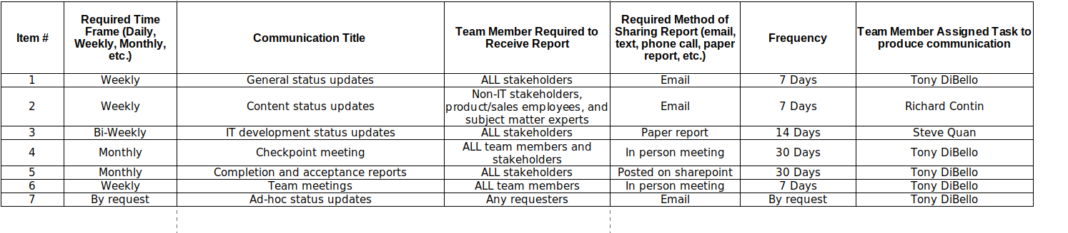

Project Control
Change Management
Changes are nearly inevitable on most projects, and since not all changes are good, “it is the responsibility of the project manager to evaluate calls for change and to implement those that will add benefits to the project work.” (MindEdge Module Eight) On a large project like this, the project manager, Tony DiBello, may be best off setting up a change control board so that decisions for changes are made based on a consensus among multiple people who have interest in the project’s results. This makes it more likely that change requests are evaluated impartially and that the best strategies for implementing the changes are chosen. DiBello should also require that change requests are submitted via a standard form that includes information such as exactly what needs to change in the project plan and why the change is necessary. Finally, he must inform any interested parties of the results of change requests, including those who submitted the request for change, regardless of the outcome.
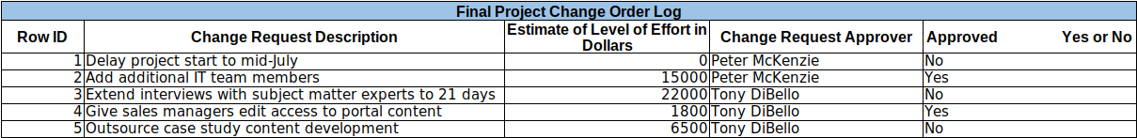

Risk Management
For a project of this size, it will be helpful to manage risk by using both qualitative and quantitative analysis in order to develop insight into potential risks and their impacts on the project outcomes. These methods will improve the team's abilities to prepare and respond to the most critical risks that the project faces. Qualitative analysis is typically less complex than quantitative analysis, and for that reason should be performed on any project. (MindEdge Module Six) Qualitative analysis involves developing ranges or scales for risk probabilities and impacts and assigning each identified risk according to its perceived rating. Tools for this technique include probability & impact matrices, sequenced lists, and risk assessment matrices. Although qualitative methods do require precise estimates or dollar amounts, numbers are often incorporated to communicate the severity of risks. For further insight, quantitative analysis uses numbers to compare alternatives and navigate complex scenarios. This is especially useful when individual risk events can have multiple possible effects on project systems and processes. (MindEdge Module Six) Tools for this technique include decision trees, sensitivity analysis, and simulations. When executed in accordance with project-specific requirements, these risk analysis techniques help practitioners develop effective risk response plans, which increase the likelihood of project success.
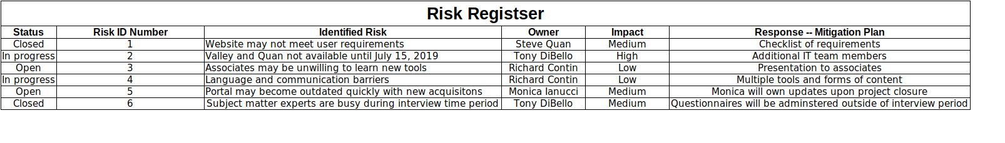
Issues Management
Similar to changes and risks, issues are almost inevitable on most projects. Issues can arise from unforeseen circumstances relating to planning, resources, and personnel. Common issues on projects can be delays on project activities or materials and conflicts between team members. These issues should be documented in a living issue log that tracks the various issues, the dates they were identified and planned to be resolved, who they were identified by and assigned to, their current status, and their proposed solution. By documenting these issues and using the document to make sure that they are in the process or being or will eventually be resolved.

Project Closeout
Close Project Process
After all of the project activities have been executed and the final deliverables are prepared accordingly, the project manager is responsible for bringing the project to a close. The closing process confirms that project is over, ensures stakeholder satisfaction, transitions the project’s results to the next user, developer, or organization, and records experiences and lessons for future reference. These lessons should be collected by all project participants throughout the project and the manager should take time to review them throughout the project life-cycle. To help accomplish effective closure and to minimize the chances that steps are overlooked, the manager, as early as possible, should visualize the final results assuming the project will be successful (MindEdge Module Nine), which will make it easier to close the project once its been completed.
Warranty Period Process
One element of the project management process that continues beyond the closure of the project is creating and fulfilling a warranty period for the products that were delivered. A warranty period can be put in place for the performing organization or for any contractors or vendors outside of the organization who created deliverables for the project. According to the Project Management Manual from the Oregon State University Department of Facilities, Infrastructure, and Operations, “the warranty period starts at the time of substantial completion” and typically lasts for one year or longer. The process during the warranty period is that any defects are notified in writing and work to remedy them should be coordinated to ensure that no additional issues will be prevalent. Finally, the project manager “should coordinate an annual warranty walk-though prior to the end of the warranty period” in order to ensure that all issues are handled and to minimize the chances that any unforeseen circumstances will arise.
Lessons Learned Template
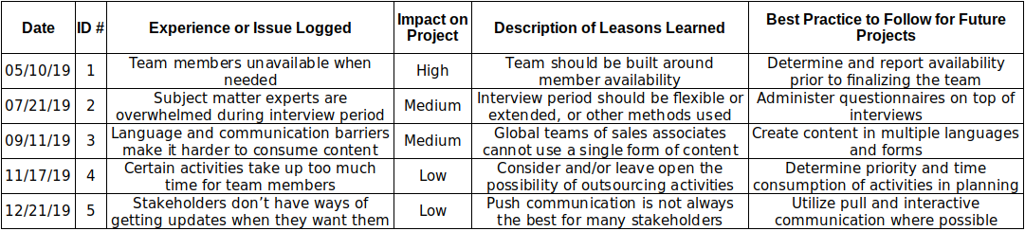
References:
Danda, Darshan. 2020. Analyze Your Project's Stakeholders With The Help Of The Salience Model. Grey Campus. Retrieved from https://www.greycampus.com/blog/project- management/analyze-your-project-s-stakeholders-with-the-help-of-the-salience-model
"Module Eight: Project Monitoring and Control.” 2021. MindEdge Inc. Retrieved from https://snhu.mindedgeonline.com/content.php?cid=87580
"Module Nine: Project Closure and Closing Stage." 2021. MindEdge Inc. Retrieved from
https://snhu.mindedgeonline.com/content.php?cid=87509
"Module Six: Project Risk Management." 2021. MindEdge Inc. Retrieved from https://snhu.mindedgeonline.com/content.php?cid=87505
"Module Three: Project Scope, Planning, and Time Management." 2021. MindEdge Inc. Retrieved from https://snhu.mindedgeonline.com/content.php?cid=87451
"Module Two: Project Selection and Initiation.” 2021. MindEdge Inc. Retrieved from https://snhu.mindedgeonline.com/content.php?cid=87513
Simmons, Marshall. “Project Crashing in Project Management: Definition & Best Practices.” 2020. projectmanager.com. Retrieved from https://www.projectmanager.com/
blog/project-crashing-definition

Warranty Period. 2021. The Project Management Manual. Oregon State University Facilities,

Infrastructure, and Operations. Retrieved from https://ufio.oregonstate.edu/pmm/50-project-delivery/510-project-closeout/5104-warranty-period

